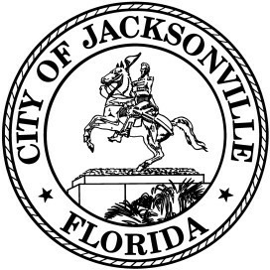

OFFICE OF THE CITY COUNCIL

Office (904) 255-5200 117 West Duval Street
Fax (904) 255-5230 City Hall, Suite 425
Jacksonville, FL 32202

Zoom Virtual Noticed Town Hall Meeting
Council members Carlucci and DeFoor- Re Lot J
October 29, 2020 at 5:00 pm
Zoom Meeting ID: 982 3247 2235
Zoom Meeting Passcode: 646651
Agenda

- Introductions (5 Minutes)

- Presentation by the Jaguars (30 Minutes)

- Public Comment (90 Minutes)

- Adjourn

